Exercise 2 – File system management
Windows Basics [TT00CD75]

Firstname lastname

- What files and folders can be found from your user’s folder?

- What is the size of all those folders combined?

- Create the folder structure presented in the image below (files can be empty). List the contents of it from command prompt using tree /F command. Does the tree listing contain all the files present in the image?
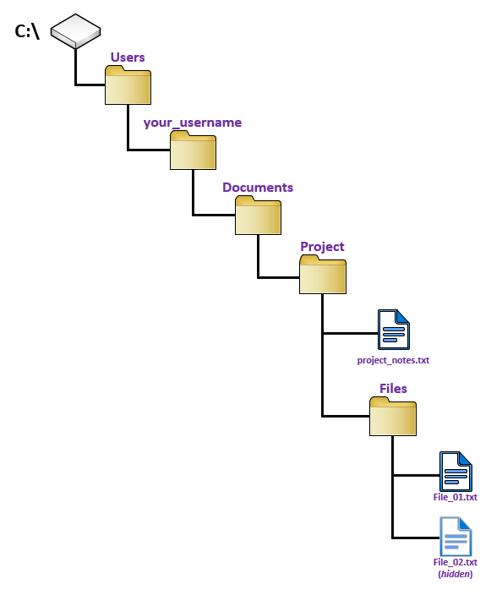
- Create a ZIP file from Project folder. The size of the Project folder is 0 bytes. How much is the ZIP file size?

- Create a shortcut of Project folder to the desktop.

- Download this ZIP package, extract its contents and place the extracted files according to given guidance (edit the folder structure to match the guidance):
- DynamicWebApp_documentation_v0.25.odt Project\Documentation\App
- Project-roles-v0.8.odt Project\Documentation\Members_and_timetable
- Project-timetable-v0.4.odt Project\Documentation\Members_and_timetable
Rerun the tree /F command in command prompt and take a screenshot from it. In addition, check how the folder size has changed?

- Create a restore point of your current operating system state. In addition, enable file history feature and create a new shared folder to C:\file_backup for your restored files.

- After creating a restore point and enabling file history feature, perform the following operations:
  - Uninstall Adobe Acrobat application (Search for Add or remove programs, then select application and then Uninstall).
  - Delete previously created Members_and_timetable folder.
Recover both of these using system restore and file history.

